|  |  |  |  |  |  |
| --- | --- | --- | --- | --- | --- |
| Description | Current | Change | Recommended | Allocation | ICR |
| BT Panorama Super | | | | | |
| INVESTMENT 9 - OTHER | $1,000,000 | $1,000,000 | $0 | 100.00% | 0.00% |
| BT Panorama Super | $1,000,000 | $1,000,000 | $0 |  |  |
| Total | $1,000,000 | $1,000,000 | $0 |  |  |

|  |  |  |  |  |  |
| --- | --- | --- | --- | --- | --- |
| Description | Current | Change | Recommended | Allocation | ICR |
| BT Wrap | | | | | |
| FI only | $0 | $200,000 | $200,000 | 33.11% | 0.00% |
| INVESTMENT 8 - MANAGED ACC | $0 | $404,000 | $404,000 | 66.89% | 0.00% |
| FI only | $0 | $5 | $5 | 0.00% | 0.00% |
| BT Wrap | $0 | $604,005 | $604,005 |  |  |
| Total | $0 | $604,005 | $604,005 |  |  |

|  |  |
| --- | --- |
| Status | Current |
| Description | BT Panorama Super |
| Balance | $1,000,000 |
| One-off Fees Subheader |  |
| Ongoing Fees Subheader | |
| - Sliding Admin Fee | $350.00 (0.04%) |
| - Admin Fee (Flat) | $480.00 |
| Subtotal | $350.00 |
| Adviser Fee (Flat) | None |
| Total | $350.00 (0.04%) |
| Comparative Total | $350.00 |

|  |  |
| --- | --- |
| Status | Recommended |
| Description | BT Wrap |
| Balance | $604,005 |
| One-off Fees Subheader |  |
| Ongoing Fees Subheader | |
| - Admin Fee (Floating) | $3,020.02 (0.50%) |
| Subtotal | $3,020.02 |
| Adviser Fee (Flat) | None |
| Total | $3,020.02 (0.50%) |
| Comparative Total | $0.00 |

|  |  |
| --- | --- |
| - Consol Balance | $604,005 |
| Adviser Fee (Flat) | None |

|  |  |
| --- | --- |
| - Consol Balance | $604,005 |
| Adviser Fee (Flat) | None |

|  |  |  |  |
| --- | --- | --- | --- |
| Status | Current | Risk Profile | Variance |
| Defensive | | | |
| Cash | 0% | 0% | 0% |
| Fixed Interest | 0% | 90.00% | -90.00% |
| Subtotal | 0% | 90.00% | -90.00% |
| Growth Subheader | | | |
| Australian Equities | 0% | 10.00% | -10.00% |
| International Equities | 0% | 0% | 0% |
| Australian Listed Property | 0% | 0% | 0% |
| International Listed Property | 0% | 0% | 0% |
| Direct Property | 0% | 0% | 0% |
| Growth Subtotal | 0% | 10.00% | -10.00% |
| Alternative Subheader | | | |
| Alternatives | 0% | 0% | 0% |
| Alternative Subtotal | 0% | 0% | 0% |
| Total | 100.00% | 100.00% | 100.00% |

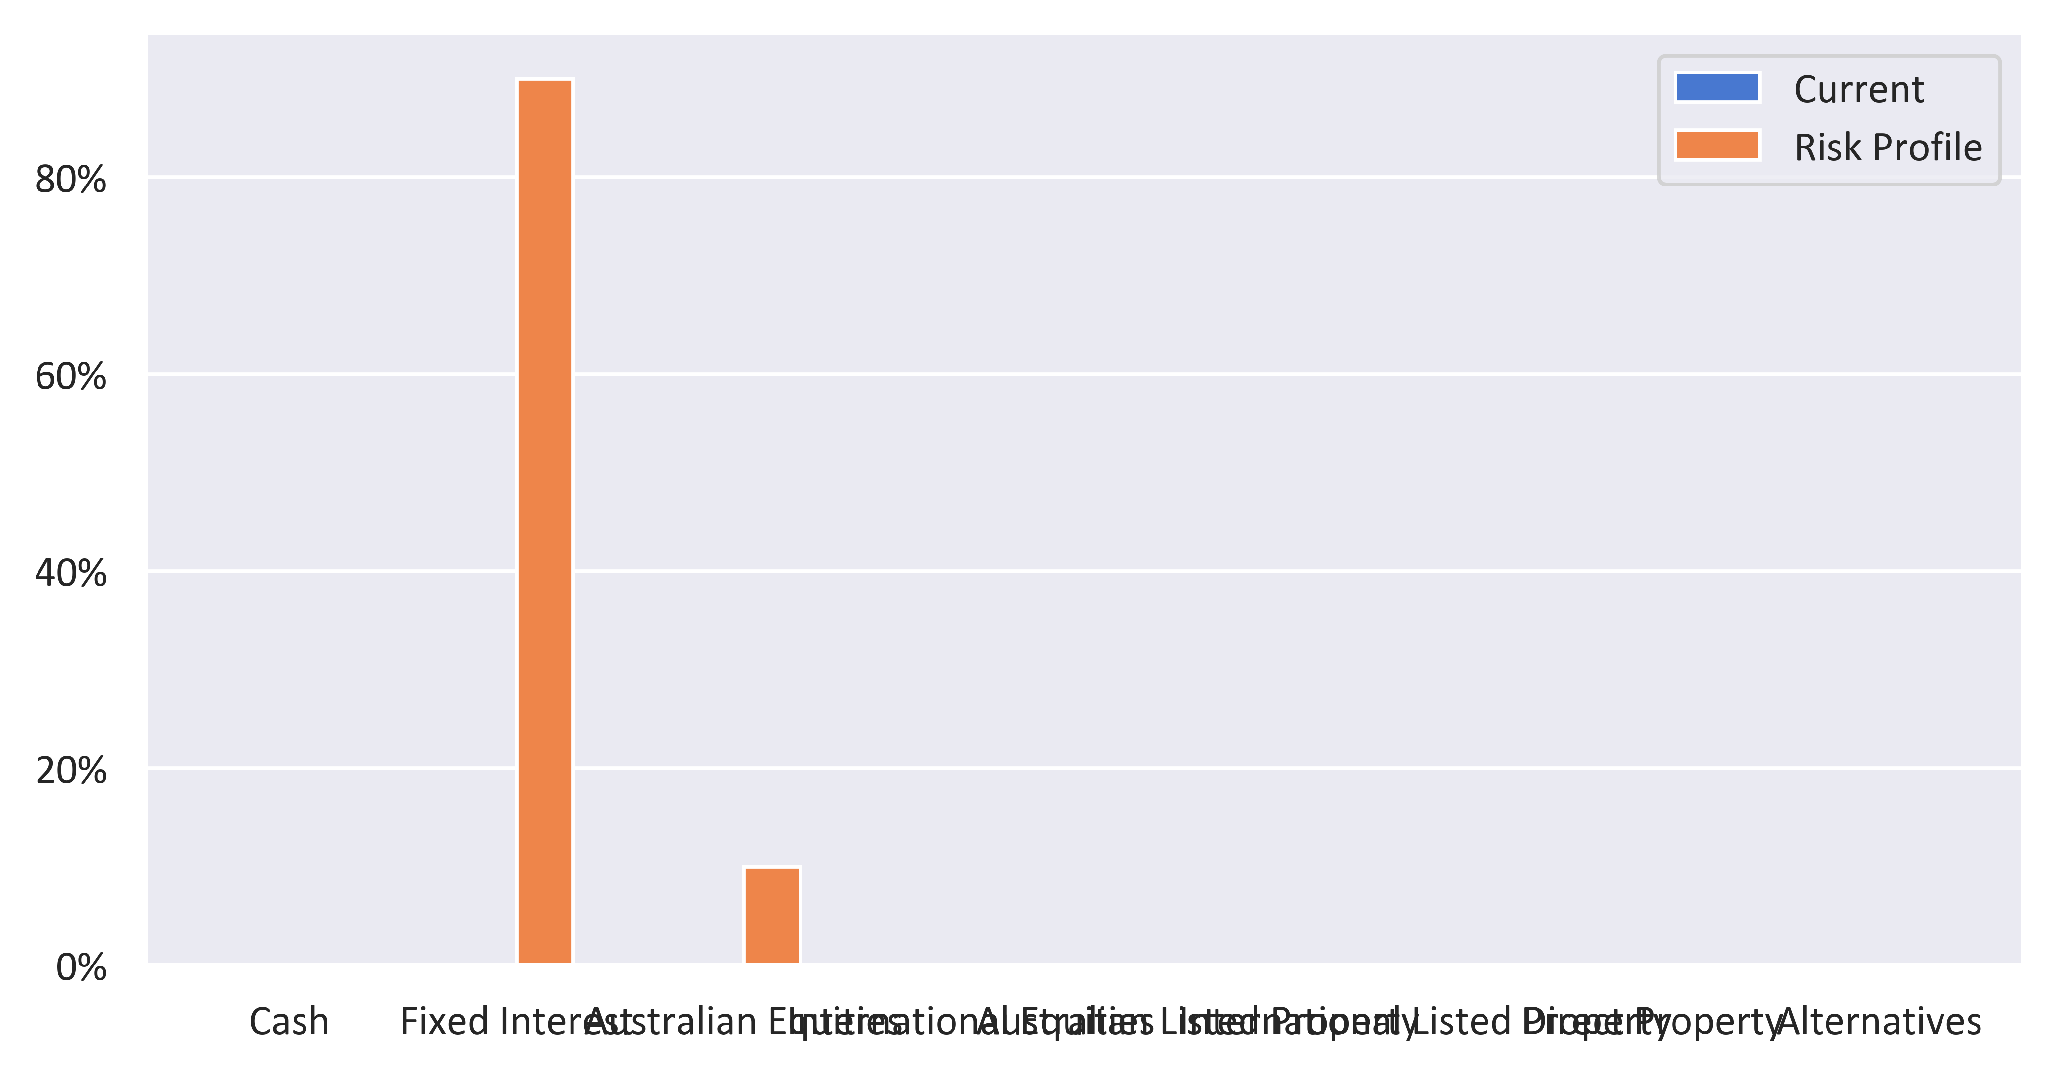

|  |  |  |  |
| --- | --- | --- | --- |
| Status | Recommended | Risk Profile | Variance |
| Defensive | | | |
| Cash | 0% | 0% | 0% |
| Fixed Interest | 0% | 90.00% | -90.00% |
| Subtotal | 0% | 90.00% | -90.00% |
| Growth Subheader | | | |
| Australian Equities | 0% | 10.00% | -10.00% |
| International Equities | 0% | 0% | 0% |
| Australian Listed Property | 0% | 0% | 0% |
| International Listed Property | 0% | 0% | 0% |
| Direct Property | 0% | 0% | 0% |
| Growth Subtotal | 0% | 10.00% | -10.00% |
| Alternative Subheader | | | |
| Alternatives | 0% | 0% | 0% |
| Alternative Subtotal | 0% | 0% | 0% |
| Total | 100.00% | 100.00% | 100.00% |

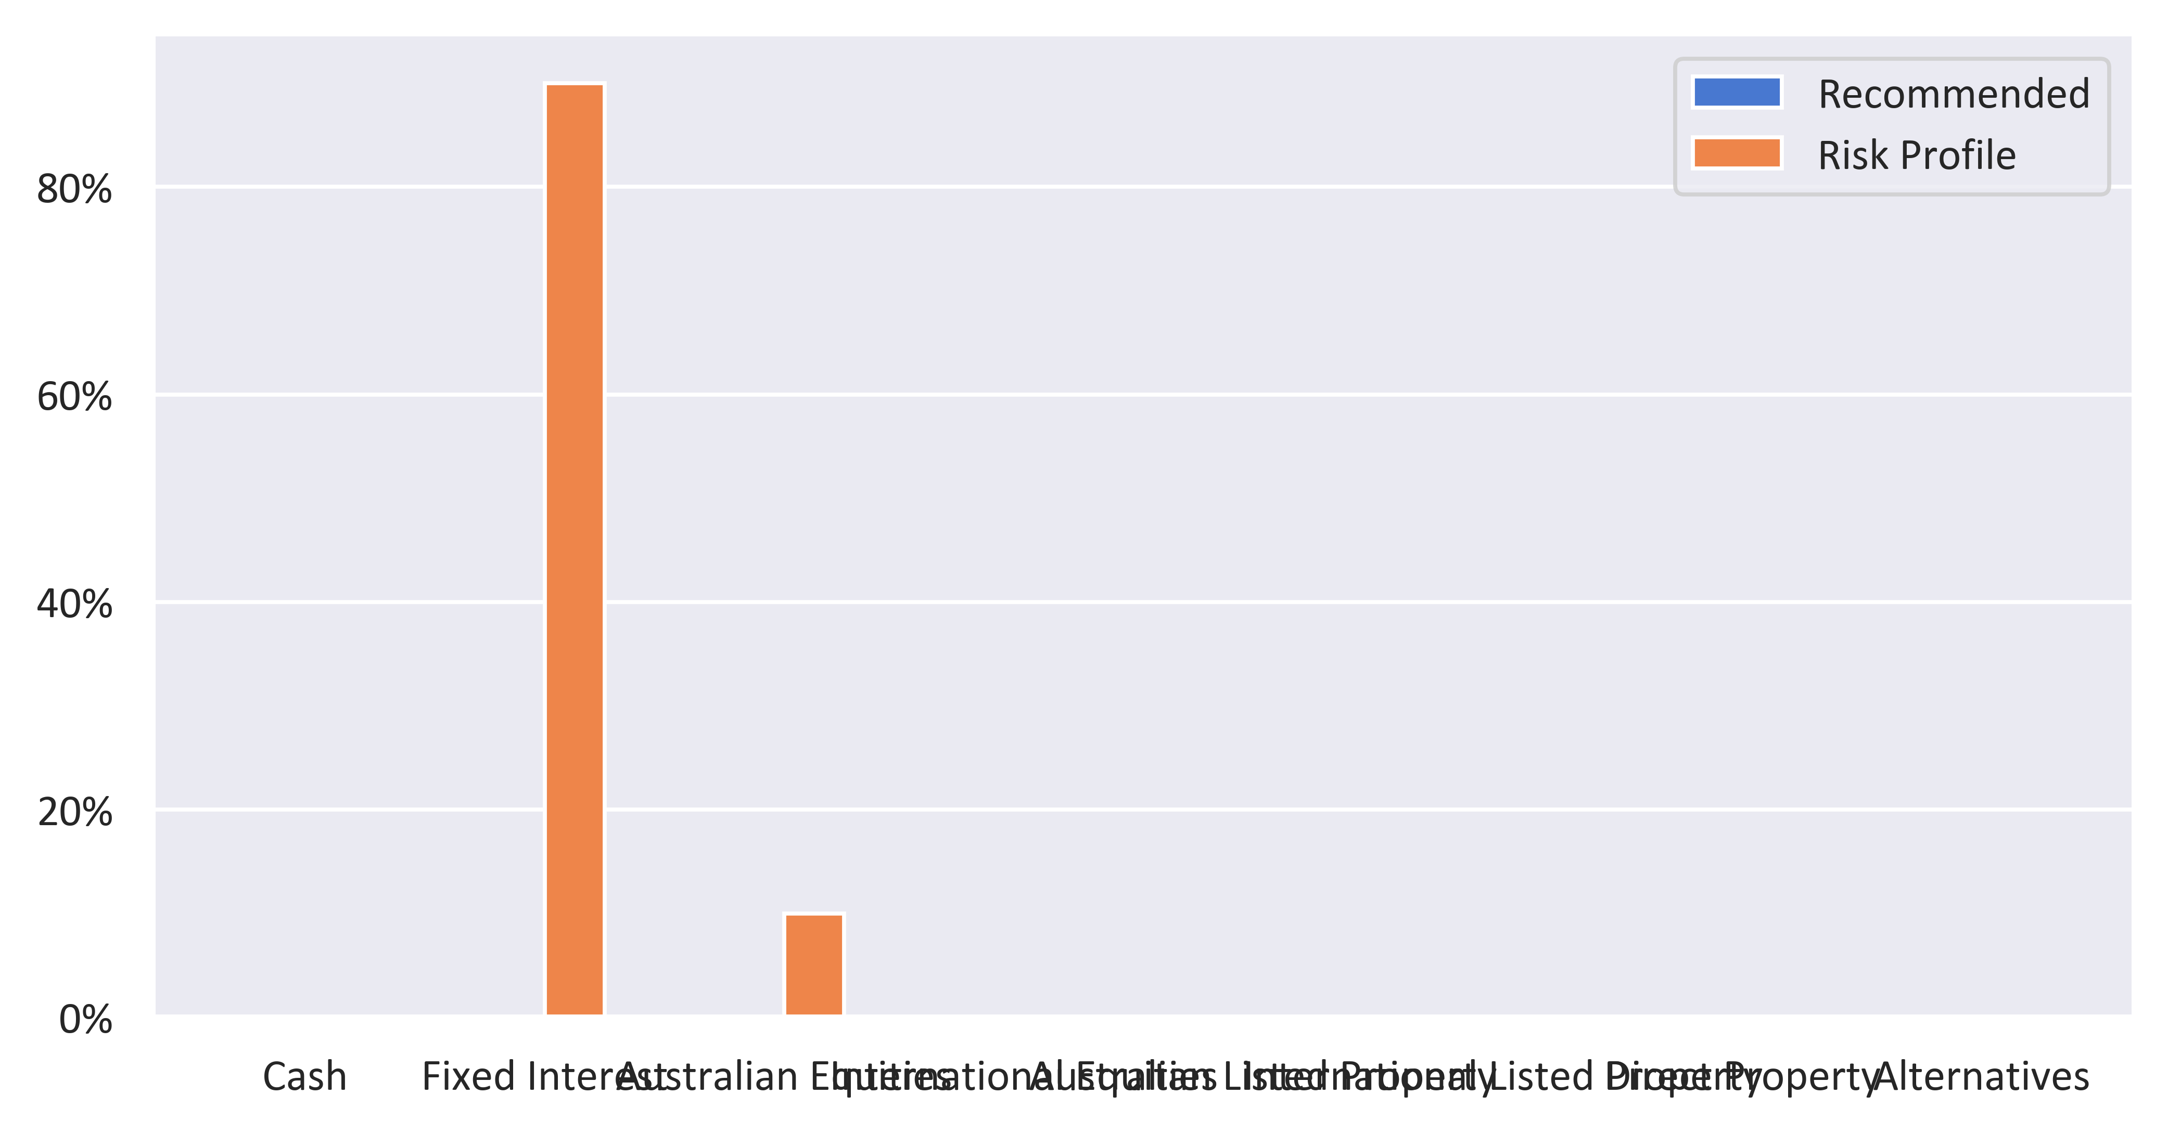

|  |  |  |  |  |
| --- | --- | --- | --- | --- |
| Status | Current | Risk Profile | Recommended | Variance |
| Defensive | | | | |
| Cash | 0% | 0% | 0% | 0% |
| Fixed Interest | 0% | 90.00% | 0% | -90.00% |
| Subtotal | 0% | 90.00% | 0% | -90.00% |
| Growth Subheader | | | | |
| Australian Equities | 0% | 10.00% | 0% | -10.00% |
| International Equities | 0% | 0% | 0% | 0% |
| Australian Listed Property | 0% | 0% | 0% | 0% |
| International Listed Property | 0% | 0% | 0% | 0% |
| Direct Property | 0% | 0% | 0% | 0% |
| Growth Subtotal | 0% | 10.00% | 0% | -10.00% |
| Alternative Subheader | | | | |
| Alternatives | 0% | 0% | 0% | 0% |
| Alternative Subtotal | 0% | 0% | 0% | 0% |
| Total | 100.00% | 100.00% | 100.00% | 0.00% |

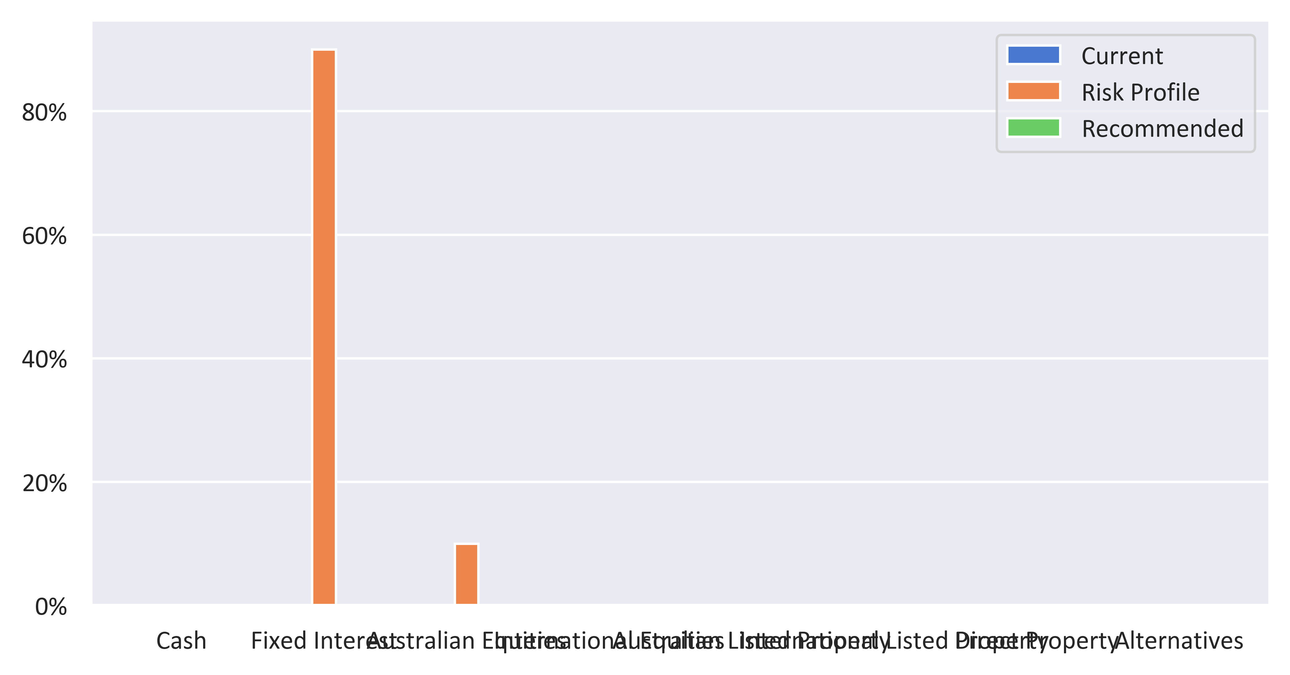

|  |  |  |  |
| --- | --- | --- | --- |
| Status | Current | Recommended | Variance |
| Defensive | | | |
| Cash | 0% | 0% | 0% |
| Fixed Interest | 0% | 0% | 0% |
| Subtotal | 0% | 0% | 0% |
| Growth Subheader | | | |
| Australian Equities | 0% | 0% | 0% |
| International Equities | 0% | 0% | 0% |
| Australian Listed Property | 0% | 0% | 0% |
| International Listed Property | 0% | 0% | 0% |
| Direct Property | 0% | 0% | 0% |
| Growth Subtotal | 0% | 0% | 0% |
| Alternative Subheader | | | |
| Alternatives | 0% | 0% | 0% |
| Alternative Subtotal | 0% | 0% | 0% |
| Total | 100.00% | 100.00% | 100.00% |

